Grade 4
Robotic Sudoku

Description: | Students will:  Draw a grid using paint tools.  Divide it into six areas.  Draw 1 motif and write a script for it.  Make five copies of the scripted motif.  Repaint each of the copies.  Put the moving motifs on Maker Buttons.  Add a flap with Sudoku rules.  Make the whole project in one class period.
Project View | 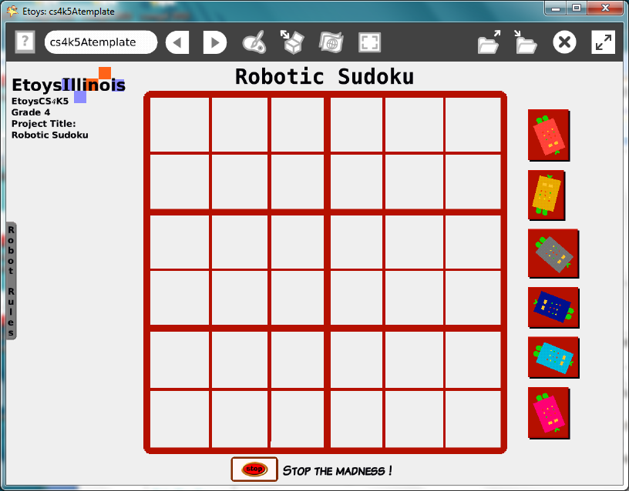
Etoys Quick Guides | Click the question mark in Etoys to open the set of interactive tutorials  for basic tools and techniques.
Vocabulary: | Planning ahead, grid, half, quarter, rows, columns, estimate, solve, patterns, rules,
Lesson 1:  Paints: Straight: Line Tools  Paints: Brushes  Script Tiles: Tests  Halo Handles: Size, Color, Copy  Object Catalog: Maker Buttons  Supplies: Text  Supplies: Add a Flap  Navigator Bar: Keep Find Projects | Give students information about this project in advance and ask them to plan ahead. Theme, designs, colors, and scripts.  Plan ahead and the project can be made in 40 minutes.  Draw the square and estimate the distances for the grid lines.  Draw a design motif.  Make a script for it that makes it move and add a test statement that keeps in inside the small squares.  Make five copies and change the colors.  Get six Maker Buttons from Supplies and put a design motif on each.  Use Text from Supplies and type a title and rules.  Add a flap for the rules and solutions.  Keep the project: NameSudoku; i.e. KateRoboticSudoku
Standards: | Common Core Standards  Mathematics: 4.G.1.3  Bloom’s Taxonomy/Cognitive Domain:  Knowledge: knows  Application: uses  NETS  - a  - b  - b
Resources: | Etoys Help Quick Guides: always available in Etoys. Open Etoys and click the question mark to open a set of interactive tutorials of basic tools and techniques.  www.etoysillinois.org projects, lesson plans, software download  www.mste.Illinois.org more math, science, and technology resources  www.corestandards.org Common Core Standards  www.squeakland.org software and Etoys projects  www.nctm.org Standards and Focal Points for each grade level
kh January 2011

